Review configuration proxy for Eclipse

1. Download Eclipse from <http://www.eclipse.org/downloads/> . In BOSCH you should to use portable version.
2. Extract zip file and then open Eclipse.exe



1. At the menu bar, click on menu Window , the click on menu Preferences like the image below

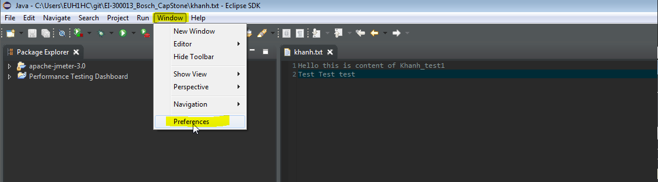

1. At the Preferences window, we click on tab General , then choose tab Network Connections

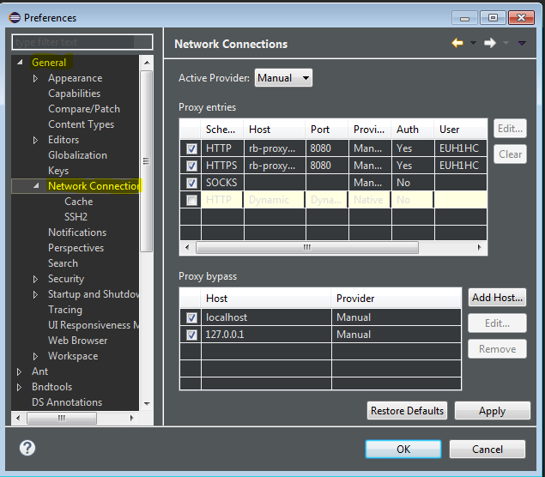

1. Click on the dropdown menu “Active Provider” and choose Manual just like the image above
2. Click on the first row then click Edit Button in the right side to set proxy for HTTP method

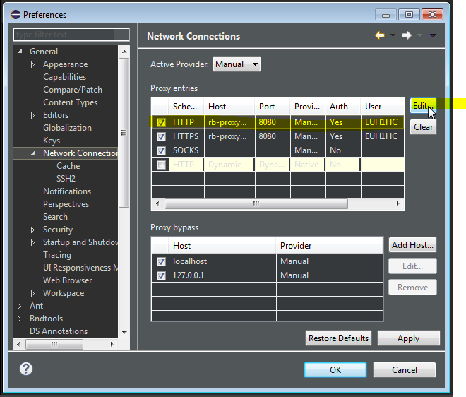

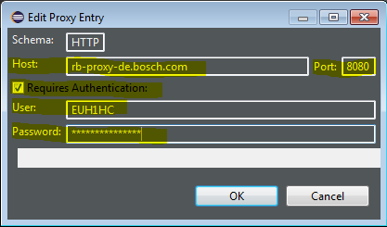

Fill out the popup window just like the image above

**Host: rb-proxy-de.bosch.com**

**Port: 8080**

**Click at the checkbox**

**User: Your User Id (which you use to login to your computer)**

**Password: Your Password**

**Then click OK**

1. At the Menu Bar, click on Help Menu and then click on Install New Update just like the picture below

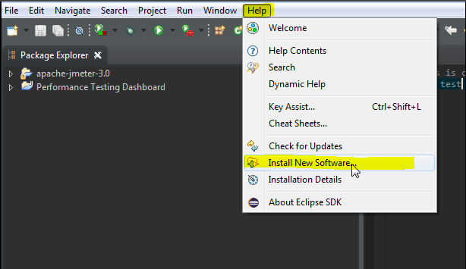

Fill out the text box “work with” with: <http://download.eclipse.org/egit/updates> to download git for Eclipse

Wait for a sec, then click choose like the image below

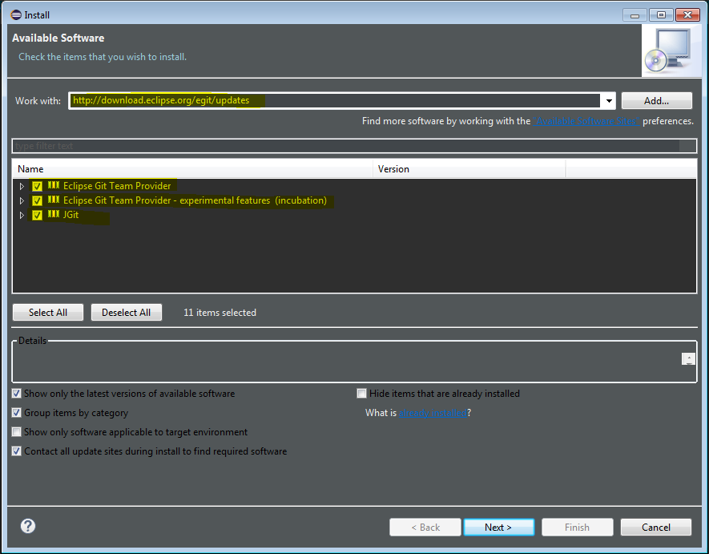

Then Click Next, Next, Next and let the machine work it works

For more information about git with eclipse, how it work or how many git’s function that you have on eclipse, go to this website for your more information:

<http://www.vogella.com/tutorials/EclipseGit/article.html#exercise-working-with-a-local-git-repository-in-eclipse>